1. Go to <https://netbeans.org/downloads/8.0/>
2. USE Java SE **DOWNLOADS**
3. 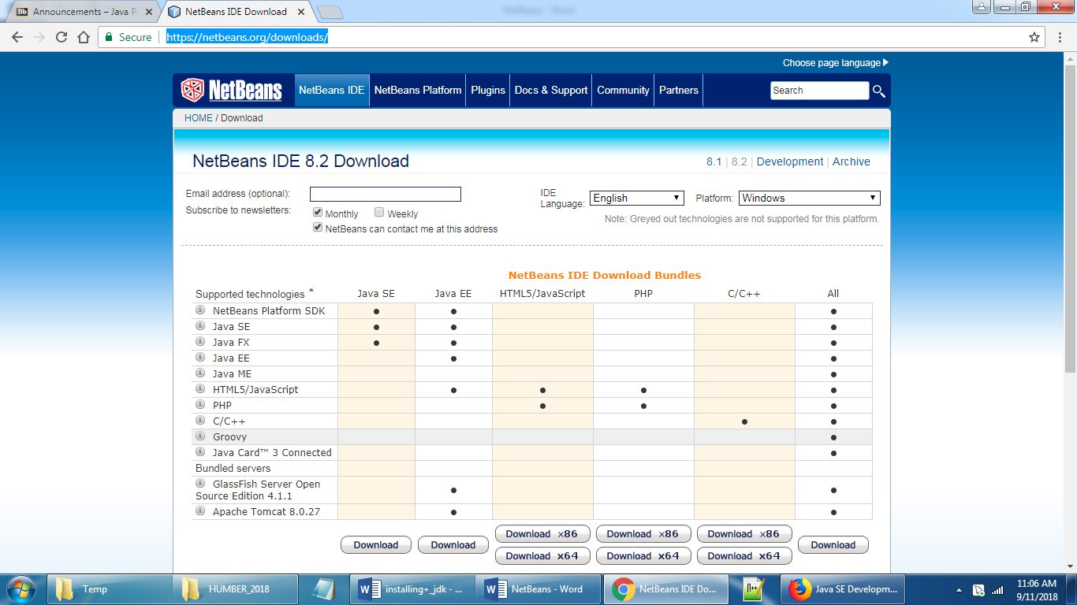

RUN the downloaded exe file

Click next on below screen

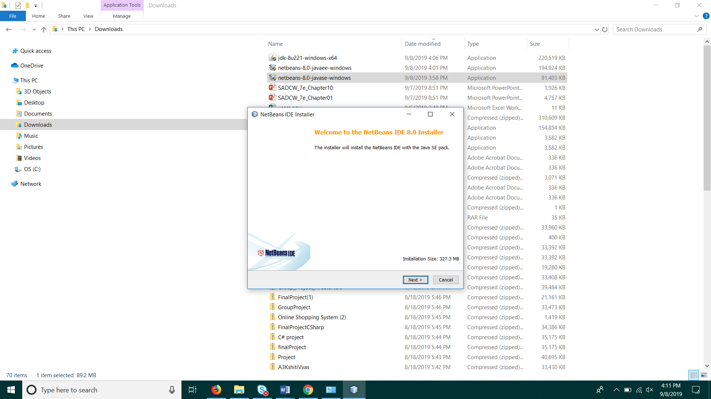

Accept the agreement

